Article Title
Title in italian

Abstract / Here there is the abstract of the article. The text should be in a single paragraph, maximum 1’100 characters, spaces included.

Keywords: keyword1; keyword2; keyword3; keyword4; keyword5. There should be maximum 5 keywords, separated by a semicolon.

Sunto / Qui viene inserito il sunto dell’articolo. Il testo deve essere un unico paragrafo, di massimo 1’100 battute, spazi inclusi.

Parole chiave: parola1; parola2; parola3; parola4; parola5. Si possono inserire al massimo 5 parole chiave che sono separate dal punto e virgola.

1 Text Format
Papers must have a number of characters between 12’000 and 110’000 (spaces included, including abstract and references) and may include images, graphs and tables. This template respects the journal formatting guidelines, that are available at this link.
The text must be written in Times New Roman, font size 12 points, line spacing 1.5.
The text must be justified and must not contain hyphens (therefore there are no truncated words when the text goes to a new line).

  - Sections
The text must be organized in sections and subsections, up to a maximum of three levels of titling (sections, subsections, and sub-subsections). Sections are numbered 1, 2, 3 etc.; subsections are numbered 1.1, 1.2, 1.3 etc.; sub-subsections are numbered 1.1.1, 1.1.2, 1.1.3 etc. The text starts right after the title of the section, in a new line. It is not necessary to leave a blank line after the title of the section.

1.1.1 Other elements
To emphasize a word or a sentence use italics, not bold nor underlined. In case one wants to suggest a “metaphorical interpretation” of a word double quotation marks may be used.
To insert a list, you can do as in the following examples.
This is an example:
- of indented bulleted list;
- of indented bulleted list.
If you want a numbered list with more than one level, you can follow this example
- First numbered element
  - First sub-element.
  - Second sub-element.
- Second numbered element
  - First sub-element.
  - Second sub-element.

1.2 Transcripts
In the transcriptions of the dialogues, you can insert the initials of the names, while in the text you can use the whole names, preferably changed so that the pupils are not recognizable. If it is necessary to make reference to specific dialogue interventions in the text, the transcripts can be numbered.
This is the conversation between Viola and Andrea.

- V.: «Yes, it is right! [looking at Figure 4]»
- A.: «I’m the best!»
- V.: «Do you want to know why it is right?»
- A.: «Mm…».
- V.: «This one [pointing to triangle $AFB$, Figure 4]? Two rectangles… if you draw a line [draws line $FH$] you have another one equal to the previous one…».

Viola understands that in Figure 4 the area of $EFGH$ is half of the area of $ABCD$ (line 1).
If no references to dialogue is needed in the text, you do not need a numbered transcript. As in this dialogue, for instance, where students have a doubt on their work:
V.: «Are we doing it in the right way?»
A.: «I think so…».
V.: «Let’s ask to the teacher».

2 Figures and tables
Figures must be entered in the text, centered and without text around them (incorporation “in line with the text”).
Every figure has a caption. The captions are identified by the word Figure: Figure 1, Figure 2 etc. and are inserted after the figures, aligned on the left, with a period at the end, leaving a blank line both before the figure and after the caption.
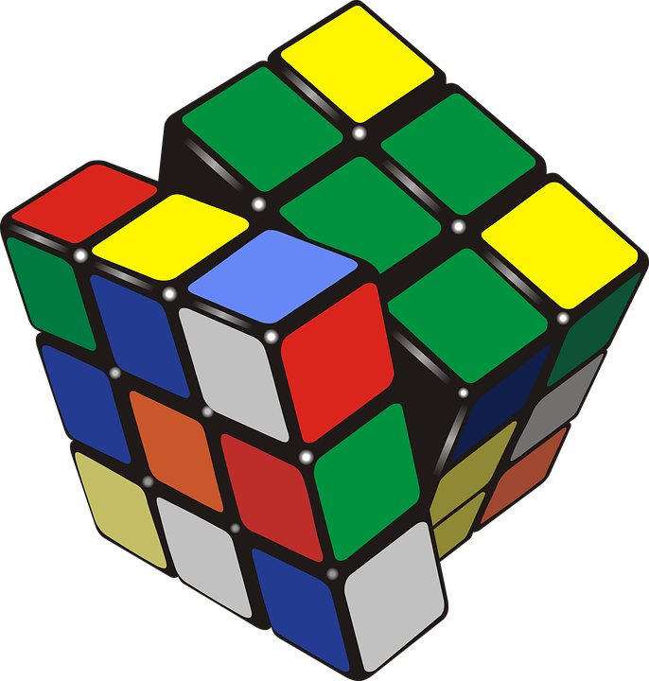
Figure 1. A picture.

The same rules apply to Tables which follows a numbering different from that of the Figures.

 | (a) | (b) | (c) | (d) | (e) | NR
N° | 33 | 12 | 28 | 28 | 28 | 5
% | 25% | 9% | 21% | 21% | 21% | 4%

Table 1. The results.

Figures and tables are referenced in line with the text, as in Figure 1 or with an undirect reference in parentheses (Table 1).

3 Quotations and references
3.1 Quotations
For direct quotations, the page number from which the reference is taken must always be stated, angle quotes must be used, not double nor single quotation marks. The same principle applies to students’ quotes/sentences. For example, consider the following paragraph.
Mathematical knowledge for teaching is, as Ball, Hill and Bass define it (2005, p. 17), «a kind of professional knowledge of mathematics different from that demanded by other mathematically intensive occupations, such as engineering, physics, accounting, or carpentry».
When text references (in quotations marks) are longer than 250 characters, they must be indented and separated from the text, leaving a blank line before and after. The bibliographic reference goes on a new line, after the quotation, aligned on the right. For example: of the same opinion are Ball, Hill and Bass (2005), stating:

«In our data, we see repeatedly the need for teachers to have a specialized fluency with mathematical language, with what counts as a mathematical explanation, and with how to use symbols with care. In addition to continuing to probe the ways in which teachers need to understand the topics of the school curriculum, and the mathematical ideas to which they lead, we will explore in more detail how mathematical language—its construction, use, and cultivation—is used in the work of teaching».
(Ball, Hill & Bass, 2005, p. 21)

In all quotations, use brackets to denote either an added text [text] or an omission […]. You can add footnote if you need. Problems and exercises can be written as an indented text paragraph, leaving a blank line both before and after the text.

Bucky the Badger is a mascot for his school football team. Every time his team scores Bucky does a number of push-ups equal to his team’s total points at that time. If his team finished with 50 points, how many push-ups could Bucky have done?

You can also insert a picture with an exercise or a problem (Figure 2).

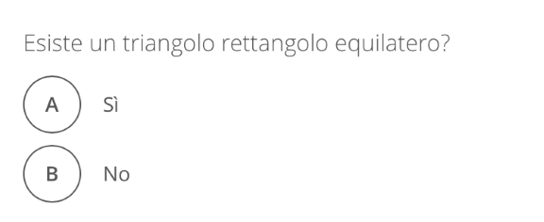
Figure 2. An exercise given to students.

Acknowledgments
If you want to thank someone, you can write it here.

References
Bibliographic references must follow the APA style. The details on how to correctly input bibliographic references are presented in APA style mini-guide for bibliographic references, published by CIRSE and available on the DdM Journal’s website (in Italian):
An example:
Piaget, J. (1979). Lo sviluppo della nozione di tempo nel bambino. Firenze: La nuova Italia.

For the protection of their privacy, students’ names were changed.

